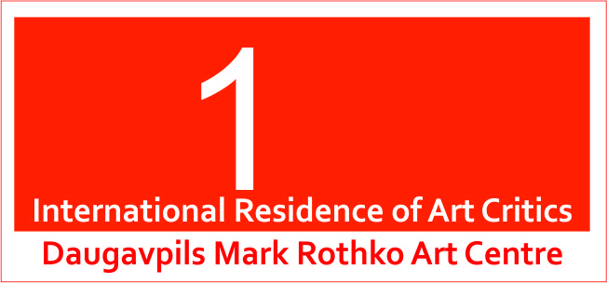

International Residences of art critics
Daugavpils Mark Rothko Art Centre
2013, June 17-21
Rules and conditions
International Residences of art critics exposes in Daugavpils, the second largest city in Latvia, a place of birth of many famous people, including the great artist-creator of abstract expressionism-Mark Rothko.
The Plein Air is the annual event, which started in 2005. During those 8 years more than 200 works have been created. It is necessary to systematize, to classify, to analyze and to divide this collection of paintings into possible parts of exposition with the help of Art Theoreticians.
During the Residence of art critics, participants are working individually as well as in groups and producing a theoretical analysis and definition. In the future this theoretical information will be used for presentations of the Daugavpils Mark Rothko Art Centre collection around the Latvian regions and in catalogues. The Residents are working on voluntary basis.
Residences of art critics are organized by: Daugavpils Mark Rothko Art Centre.
Residences’ partners: Daugavpils Museum of Regional Studies and Art, Daugavpils Secondary School ,,Saules skola”, Daugavpils University, Daugavpils regional artists’ association.
The objectives of Residences:
1. To attract attention to the Daugavpils as a city, populated by creative people interested in the Arts.
2. To provide with a scientific research of the Daugavpils Mark Rothko Art Centre’s collection by the Residents.
The Residence Venue: Daugavpils Mark Rothko Art Center, Latvia.
The Residence Time: 2013, June 17th -21st.
The Residents are: professional Artists - Art Theoreticians.
Ten of art theoreticians are participating in the International Residences for Scientists of Art.
The selection of the participants will be held on a competitive basis: CV, application form and example of a theoretical analysis, a material for exhibition annotation or review for a catalogue.
Organizers responsibilities (residence participants are provided with):
1. Accommodation costs (hotel and meals);
2. Transfers (The International Airport “Riga” – Daugavpils, return trip);
3. Studios;
4. Working materials: Daugavpils Mark Rothko Art Centre collection funds, library, stationery, and computers;
5. Publicity: advertising in mass media and publication of the annotation and catalogue;
6. Cultural program: tour around the city and the region, visiting educational art establishments in Daugavpils.
Artists Responsibilities (residents provide with):
1. Travel costs from Daugavpils to Riga or backwards, return trip;
2. Materials and tools required for work;
3. Participant should have a Health Insurance;
4. Presentation of the participant’s experience in art theory (visual materials);
5. Works of the Art Theoreticians in the project, reserved by the author’s rights, is the property of the Daugavpils Mark Rothko Art Centre;
6. During 10 days after receiving the invitation letter, Artist needs to confirm his participation (until April 10th, 2013)
How to apply:
The application form should be sent starting from March 1st 2013 till March 30th 2013 by e-mail.
1. Fulfilled Application Form (computer text);
2. Artist’s CV;
3. Presentation materials (an example of exhibition annotation or review for a catalogue).
Application form and CV should be sent starting from April 1st, 2013 until April 30th, 2013 to e-mail address below:
maris.cacka@daugavpils.lv
Application forms should be sent by e-mail only.
Applications will be evaluated and the invitations will be sent to participants of the International Residences for Scientists of Arts in Daugavpils Mark Rothko Art Centre until April 1st 2013.

Organizing committee address:
Daugavpils Mark Rothko Art Centre
Mihaila street 3, Daugavpils, LV5401, Latvia
www.rothkocenter.com
https://www.facebook.com/DaugavpilsMarkRothkoArtCentre

